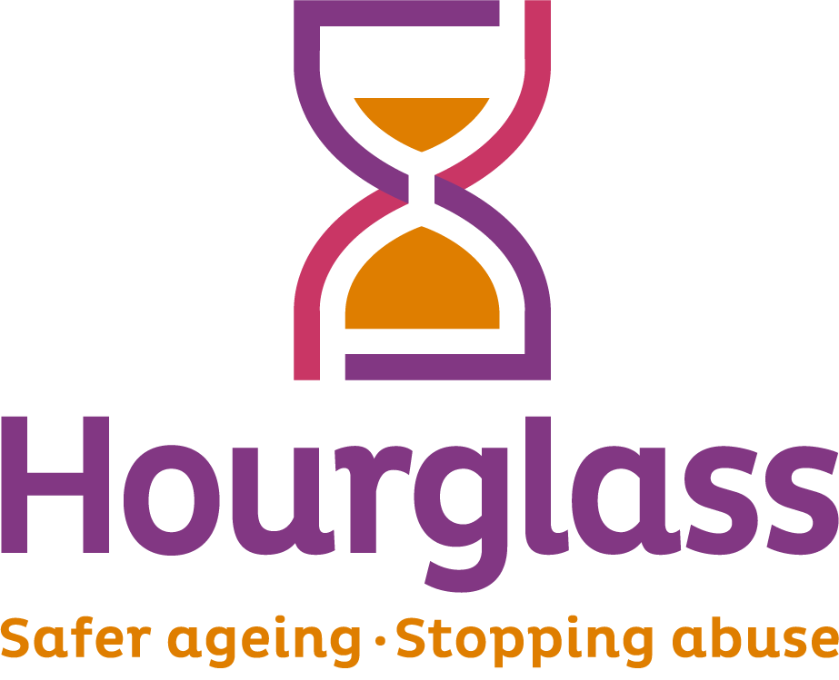
Job Description

Job title: | Communications and Press Officer
Location: | The role will be based full time in the Sudbury, Suffolk office
Duration: | One-year fixed term with extension subject to funding
Salary: | £25,583 – £28,016 per annum depending on experience
Hours of work: | 35 hours per week – Monday to Friday  9am - 5pm. Some out of hours work may be required.
Reports to: | CEO and DCEO
Responsible for: | n/a
Job Description last reviewed: | March 2026

About Hourglass:
Hourglass is the only UK-wide charity dedicated to ending the abuse, harm, exploitation and neglect of older people. We work across the UK to create a safer ageing society, support older victim-survivors, and influence systems, services and policy so that abuse in later life is better understood, better prevented and better addressed.
Abuse of older people remains under-recognised and too often hidden. It can take many forms, including domestic abuse, coercive control, economic abuse, psychological abuse, sexual abuse, neglect and harm within families, relationships and care settings. Older victim-survivors are frequently overlooked within public debate, media narratives and policy responses. Hourglass exists to change that.

About the role:
The Communications and Press Officer plays an important role in raising awareness of Hourglass’ mission, services, impacts and policy asks. The postholder will help shape how the organisation presents itself publicly, ensuring that the abuse of older people is communicated with clarity, authority and sensitivity.

This role combines media relations, press handling, content development and public affairs support. The postholder will respond to media requests, identify opportunities to secure positive coverage, assess the news value of research findings and government policy or framework documents, and work closely with senior colleagues to turn complex evidence and policy issues into clear, compelling communications.

The Communications and Press Officer will also support the development of thought leadership content, including podcasts, opinion pieces, blogs and online commentary for senior staff, and will work closely with the External Affairs team to strengthen the organisation’s narrative for lobbying, campaigns and related media opportunities.

Key Responsibilities:
Media and Press
- Draft, edit and distribute press releases, reactive statements, media lines, briefings and comment pieces.
- Respond to media enquiries in a timely, professional and well-judged way, including helping to coordinate interviews, quotes and background briefings.
- Build and maintain constructive relationships with journalists, producers, editors and relevant media outlets.
- Identify proactive media opportunities which raise awareness of the abuse of older people, Hourglass’ work and the need for systemic change.
- Support senior spokespeople to prepare for interviews and media appearances, including drafting briefing notes and key messages.
- Monitor breaking news, emerging debates and relevant public interest stories to identify opportunities for Hourglass to contribute expert comment.
- Maintain press records, media contact lists and coverage logs.

Strategic Communications
- Help develop and deliver communications activity that supports organisational priorities, campaigns, services and public engagement.
- Assess the communications and news value of new research, consultation responses, statistics, government strategies, policy frameworks and legislative developments.
- Translate complex information into clear, engaging and accessible content for public, professional and stakeholder audiences.
- Work with the External Affairs team to develop strong public narratives that support lobbying activity, campaigns and influencing work.
- Help ensure consistency of tone, message and language across press, digital and organisational communications.
- Contribute to messaging which reflects the realities of abuse in later life, including links to domestic abuse, safeguarding, ageing, gender and VAWG.

Content and Digital
- Write and edit content for the website, blogs, newsletters, social media and other digital channels.
- Support the planning and production of blogs, online articles, podcasts and thought leadership content for senior members of staff.
- Help generate ideas for campaigns and content that improve public understanding of older victims’ experiences and Hourglass’ role.
- Work with colleagues to create case studies, features and campaign materials which are accurate, sensitive and impactful.
- Support the development of leaflets, promotional materials and other communications assets in collaboration with relevant teams and suppliers.

Monitoring and Insight
- Monitor media coverage and sector developments relevant to the abuse of older people, safer ageing, domestic abuse and Violence Against Women and Girls (VAWG).
- Keep abreast of the wider media landscape, including how older people, abuse, gender-based violence and related policy issues are being covered.
- Track communications performance and media coverage, and provide reports or summaries to support learning and planning.
- Identify trends, risks and opportunities in public discourse that may affect Hourglass’ work, reputation or strategic messaging.

Cross-Organisational Working
- Work closely with the External Affairs team on public affairs and media opportunities linked to influencing priorities.
- Collaborate with fundraising colleagues to support campaigns, appeals, events and other public-facing activity.
- Work with service delivery and operational colleagues to understand the charity’s work and identify stories, insight and evidence that can be communicated externally.
- Support internal planning around key dates, campaigns, reports and announcements.
- Uphold safeguarding, confidentiality and ethical standards in all communications, particularly when handling sensitive case studies or victim-survivor stories.

Person Specification
Essential
- Excellent writing, editing and verbal communication skills, with the ability to write clearly for different audiences and channels.
- Experience of producing press releases, statements, briefings or other media-facing content.
- Experience of responding to media enquiries and dealing professionally with journalists or external stakeholders.
- Strong understanding of the media landscape and how news stories are developed.
- Ability to assess the news value of policy, research and public affairs developments and turn them into usable media or communications opportunities.
- Experience of producing digital content for websites, blogs, newsletters or social media.
- Strong organisational skills, with the ability to manage competing priorities and work to deadlines which may be at short notice.
- Sound judgement, including the ability to handle sensitive issues carefully and appropriately.
- Ability to work collaboratively across teams and with senior staff.
- Commitment to the values and mission of Hourglass.
- Ability to work unsocial hours as required.

Desirable
- Experience in a charity, public affairs, campaigning or policy environment.
- Knowledge of issues affecting older people, including abuse, safeguarding, domestic abuse or safer ageing.
- Understanding of Violence Against Women and Girls and how older women may be overlooked within those conversations.
- Experience of supporting spokespeople, drafting interview briefings or preparing senior staff for media opportunities.
- Experience of shaping podcasts, blogs, opinion pieces or other thought leadership content.
- Familiarity with monitoring media coverage and using insight to improve communications activity.

Additional Qualities
The successful candidate is likely to be:
- A strong and thoughtful writer who can handle both reactive and planned communications.
- Curious and alert to public debate, policy change and media opportunities.
- Sensitive to the realities of abuse and able to communicate difficult issues with care and authority.
- Comfortable working in a small, mission-driven environment where teamwork and initiative both matter.
- Motivated by the opportunity to help bring greater visibility to an issue that is too often ignored.

