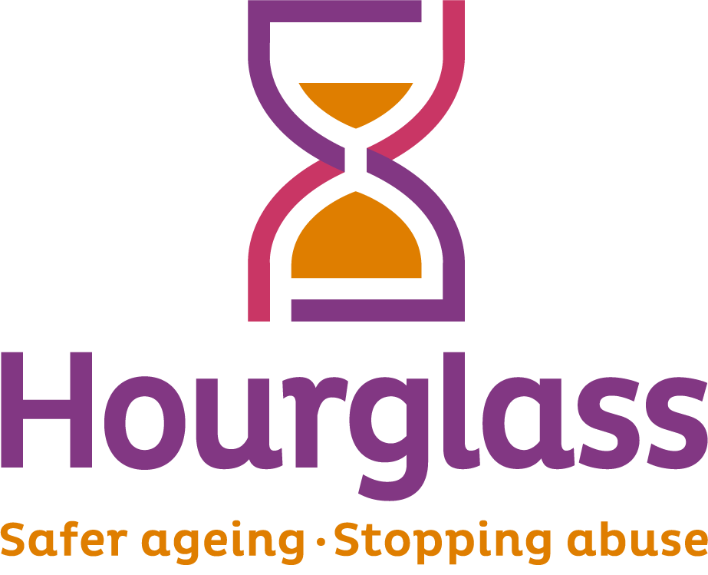
Job Description

Designation: | Information and Data Officer
This post normally reports to: | Deputy CEO/Director of Policy (TBC)
This post has directed line management responsibility for: | Currently no direct line management responsibility.
Job Description last reviewed on: | May 2025
Hours of work: | 35 hours Monday to Friday
Current Salary: | £24,838.00 PA
Location: | Home-based initially (although the post-holder will be expected to move to an office location in due course)

Information Officer: Person Specification

Essential Criteria – Candidates will be expected to demonstrate how they can deliver against these criteria.

- Experience of creating, administrating, and maintaining electronic information repositories or resources, including those related to CRMs/Databases
- Ability to produce high quality, accurate statistical reports for a variety of audiences
- Self-motivated, with an ability to think creatively to solve problems and use own initiative, requiring minimal supervision
- Experience of supporting/working with vulnerable or older people, and/or an ability to interact with content relating to potentially distressing subject matter.
- Ability to manage a complex and varied workload, and manage confidential issues
- Good working knowledge of Excel
- Degree level education or equivalent experience.
- Experience of working with large data sets including proven analytical skills
- Ability to work to tight deadlines and balance competing priorities
- Excellent verbal and written communication skills, including ability to translate complex or nuanced data points to a variety of audiences.

Desirable Criteria:

- Interest in VAWG, domestic/sexual abuse and violence prevention, or health and social care/safeguarding
- Project management experience, including delivering successful and impactful projects
- Knowledge of evaluation and monitoring processes
- Experience of working in the charity/NGO sector
- Experience of working on a Helpline, Information Services or equivalent
- Knowledge or lived experience of domestic/sexual abuse, intervention or prevention.

1. CONTEXT AND PURPOSE OF JOB:

  - Hourglass is the only UK-wide charity dedicated to calling time on the harm, abuse, exploitation and neglect of older people. We support older people experiencing, or at risk of, harm, abuse or exploitation, and seek to create a safer ageing society for all.

  - We are seeking an Information Officer to lead on collating and presenting the charity’s impact information, while curating, maintaining, and updating the Knowledge Bank - the UK’s first online information repository wholly focused on the abuse of older people and safer ageing.

The role has also been developed to ensure Hourglass data is of a high quality for reporting to a variety of internal and external audiences. The Information Officer, as part of the Policy Unit, will work alongside all operational teams who record data including contacts to the Helpline, Knowledge Bank, Instant Messenger, SMS and Chatbot. The role will also look at data on types of abuse, and demographic information to help contribute to the development of one of the largest non-governmental data sets about the extent of the abuse of older people in the UK, as we move towards a Safer Ageing Society.

2. MAJOR DUTIES AND RESPONSIBILITIES:

  - KNOWLEDGE BANK

    - With support from colleagues, co-ordinate regular updates and maintain the Hourglass’ online Knowledge Bank to strengthen and enhance our well-established 24/7 Helpline. Duties include:
  - liaising with relevant staff to coordinate the technical aspects of the ongoing operation of the Knowledge Bank
  - working with colleagues across the charity to identify and collate the data and content needs for the Knowledge Bank, including internal and external content, and creating new content
  - updating the Knowledge Bank on a regular basis
  - working with the wider team to ensure the ongoing promotion of the Knowledge Bank to a variety of audiences across the UK.

    - To ensure effective streamlining between the Knowledge Bank and other charity support products, including our Helpline call handling system, Customer Relationship Management database, website and other processes.

    - To ensure the delivery of the Knowledge Bank meets all legal requirements relating to data protection/GDPR, confidentiality, safeguarding, risk assessment, equalities etc.

    - To ensure all software, databases and equipment are fit for purpose, and staff and volunteers have the relevant support to use them.

  - ONLINE SERVICES: Instant Messenger, Text Message System & Chatbot

2.2.1 To ensure the smooth functioning of the instant messenger and chatbot and ensure these functions complement both the Knowledge Bank and the overall Frontline Services offering; ensuring staff/volunteers have the necessary information.

    - With colleagues, review other innovations designed to provide real-time information to service users requiring advice and guidance relating to the abuse of older people and safer ageing.

    - To support the creation of a range of online and paper-based information resources to facilitate access for services users who cannot access electronic information resources, as well as a means of providing follow-up support for service users.

    - To identify and coordinate the need for information in alternative formats to meet the needs of services users with disability-related needs or those requiring support in languages other than English.

3. DATA INPUT AND ANALYSIS

3.1 Usage of data and good practice

3.1.1 Complete data cleaning for Frontline Service cases in line with Helpline data standards.

3.1.2 Review Frontline Services cases and attached records to ensure data standards are being adhered to and case information is correctly entered on the Hourglass CRM/database.

3.1.3 Demonstrate strong understanding of Frontline Services case classifications and escalate errors to the appropriate staff members.

3.1.4 Support Policy and Frontline Service management in formalising data standards and reporting guides and ensure these are kept up to date.

3.1.5 Support the Policy and Frontline Service teams in implementing data model changes and basic database/CRM changes such as creating and updating fields and objects, implement validation rules and update page layouts.

3.1.6 Contribute well-informed suggestions for updates to the bespoke data model implemented by Frontline Services and periodically collect (and implement as agreed) suggestions made by the wider team.

3.2 Analysis & Reporting

3.2.1 Utilise database/CRM reporting functions and analyse in Excel, using a methodical approach and skills such as formulas, pivot tables, power query to ensure consistent output and data accuracy.

3.2.3. Export call data using cloud based reporting functions and analyse in
Excel – or similar.

3.2.4 Contribute to completion of a range of anonymised aggregate reports for internal and external audiences including the Hourglass annual report, ad hoc/thematic reports, fundraising grant end reports, bespoke reports and academic collaborations.

3.2.7 Support with pulling and analysing data for bespoke reports in collaboration with the Policy Unit and external stakeholders such as academics. Support Hourglass’s Brand, External Affairs and Fundraising and Communications functions with reporting as required.

3.3 Data Security

3.3.1 Maintain compliance with data protocols around collection, processing, storing and sharing data to ensure confidential, sensitive information is securely and responsibly stored, processed and shared. The postholder must maintain confidentiality and observe requirements of the Data Protection Act 2018.

3.3.2 Understand and keep abreast of policies and protocols related to the effective operation of Frontline Services and other services - particularly in relation to data requirements and processes. Understand and comply with all relevant legislation and adhere to organisational and operational policies and procedures. This would include confidentiality protocols.

4. TRAINING & DEVELOPMENT

4.1 Model best practice in data quality and contribute to a culture of continuous improvement.

4.2 Support the creation of resources and guidance for staff around data standards, data quality and data cleaning as required. Support with induction and ad hoc training around the database/CRM, data standards, data cleaning and data quality as required. Utilise feedback mechanisms to keep Policy and Frontline Service teams informed about the quality of data input.

4.3 To undertake occasional 1-2-1 support sessions with staff and volunteers ensuring they understand best practice in using and utilising Hourglass data, providing advice and guidance in accordance with good practice and Hourglass policy. To help coordinate the design and delivery of training materials for Frontline staff and volunteers, for each of the online entry points.

5. GENERAL DUTIES

5.1 The Information Officer will also be expected to:

- travel as required to meet the requirements of the role (including occasionally across the UK)
- work unsocial hours on occasions and be flexible with working pattern as and when required
- regularly liaise with other Hourglass staff and volunteers throughout the UK
- The post holder must at all times carry out their responsibilities with due regard to Equality legislation and the charity’s Equality, Diversity and Inclusion Policy. The post holder is required to be familiar with Health and Safety legislation and the Hourglass Health and Safety Policy and be aware of and observe any part of the policy related specifically to the duties and responsibilities of the post.
- The duties and responsibilities highlighted in this job description may vary over time.
- Postholders are expected to undertake other duties and responsibilities relevant to the nature, scope and grading of the post.

