# 

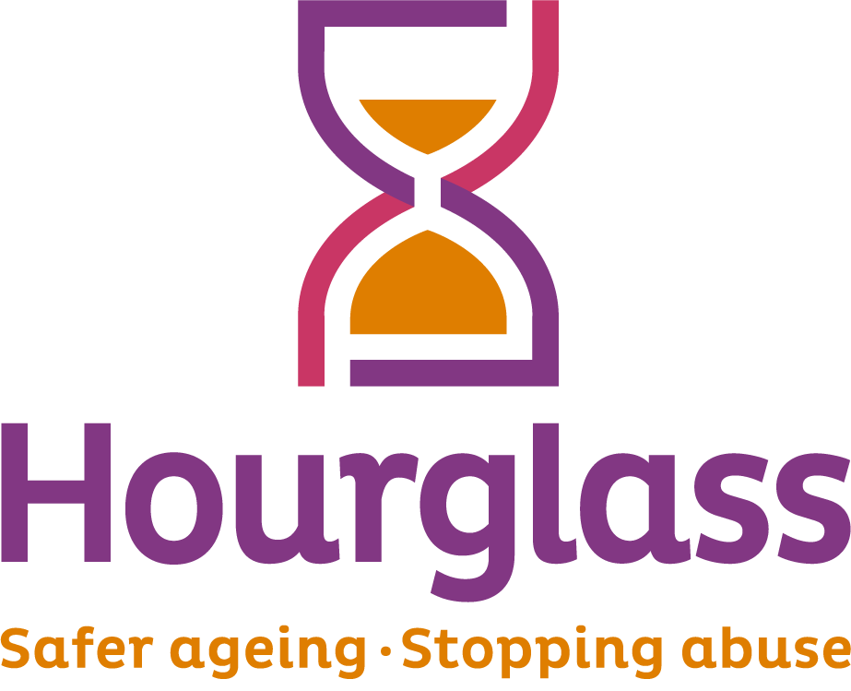

**Job Description**

|  |  |
| --- | --- |
| **Job title:** | **Frontline Services Officer (Helpline)** |
| **Location:** | Sudbury Office |
| **Duration:** | 1 year initially - subject to funding |
| **Salary:** | £24,050 per annum (35 hour per week)  Job share may be available depending on needs of the charity. |
| **Hours of work:** | 35 hours (Monday to Friday, 9am – 5pm) |
| **Reports to:** | Frontline Services Lead |
| **Responsible for:** | None. But will provide support to Helpline volunteers |
| **Job Description last reviewed:** | Feb 2025 |

**Job Outline**

The Frontline Services Officer (Helpline) will be the first point of contact for older people at risk of harm, their families, and professionals seeking support. They will provide crisis intervention, safeguarding guidance, and practical support while ensuring high-quality signposting and referrals

**1. CONTEXT AND PURPOSE OF JOB:**

* 1. Hourglass is the only charity in the UK dedicated to calling time on the harm, abuse and exploitation of older people. We support older people experiencing, or at risk of, harm, abuse or exploitation, and work towards a fairer society for all older people.
  2. Hourglass’s integrated frontline service offers a unique and innovative solution to combat and prevent the abuse of older people. This service provides immediate assistance in times of crisis while also offering long-term, person-centred care that empowers older adults and ensures they are protected, valued, and connected to their communities.
  3. Working within the Frontline services team on the Helpline, you will be an immediate point of contact for our victims/survivors, family members and others concerned about older people who may be experiencing abuse, harm or neglect. Providing immediate responses to callers such as contacting local authorities, offering safety advice, or supporting a victim/survivor with contacting others for support needs.

**2. MAJOR DUTIES AND RESPONSIBILITIES:**

**2.1 HELPLINE**

2.1.1 To provide information, advice and support to older people relating to support options for older people experiencing (or at risk of abuse), and safer ageing. To provide accurate and appropriate information and support via telephone, email and other electronic methods, and assist callers to explore their options.

2.1.2 To provide practical and initial emotional support to service users, assessing the nature of each call/enquiry and responding in an empathetic and supportive manner. To ensure service users receive advice and support which is appropriate to their needs in a non-judgmental manner and which clearly identifies realistic and achievable options.

2.1.3 To assess and respond to emergency or high-risk calls, ensuring appropriate escalation, safeguarding referrals, and risk management in line with organisational policies.

2.1.4 To provide a triage service for our frontline team, onboarding referrals, offering safety advice, making safeguarding referrals and liaising with other organisations on behalf of service users to support their needs.

2.1.5 To undertake follow up contact with service users on a pre-determined basis to provide further support and/or ascertain outcomes.

2.1.6 To explain safeguarding approaches to service users in a way that they can best understand, respecting their needs to receive as correct and as full information or advice as they are able to do, providing them with emotional support, and treating them with dignity and respect.

2.1.7 To notify the Frontline Services Lead or a member of management of any circumstances in which there may be immediate risk to a caller and to act as authorised.

2.1.8 To identify service users who may be willing to speak to the media, bringing these to the attention of the Frontline Services Lead or other member of the management team.

2.1.9 To identify own needs for support, including emotional support, and use support services as needed. To attend and participate in training events as required.

2.1.10 To ensure the Helpline section is ready for operation at the commencement of shifts, and to provide support to volunteers where required.

2.1.11 To recognise, assess, and respond to safeguarding concerns, ensuring all appropriate procedures are followed in line with Hourglass’s safeguarding policy and statutory requirements.

**2.2 INFORMATION**

2.2.1 To assist colleagues with the issuing of promotional material on conferences, seminars, fundraising, the frontline services and other services, as required.

2.2.2 To undertake research through telephone and internet to identify statutory, voluntary or other agencies or individuals who could receive information to publicise the frontline services and other charity services.

2.2.3 To distribute follow-up information materials to Frontline service users via post, email or other electronic methods.

**2.3 RECORD KEEPING AND INFORMATION SHARING**

2.3.1 To maintain accurate records using our Customer Relationship Management (CRM) database and other internal records.

2.3.2 To share relevant information relating to calls/enquiries with colleagues in line with organisational practice relating to data protection and confidentiality

**2.4 GENERAL**

2.4.1 In the absence of management, to ensure Helpline volunteers are supported in line with organisational policy, including regular breaks during shifts, providing advice and support, and regular de-briefing.

2.4.2 To undertake administrative support as required.

2.4.3 To attend regular team and charity wide meetings.

2.4.4 To travel as required, such as to charity events and conferences.

2.4.5 The postholder must maintain confidentiality and observe requirements of the Data Protection Act.

2.4.6 The post holder must at all times carry out their responsibilities with due regard to Equality legislation and the charity’s Equality, Diversity and Inclusion Policy.

2.4.7 The post holder is required to be familiar with Health and Safety legislation and the Hourglass Health and Safety Policy and be aware of and observe any part of the policy related specifically to the duties and responsibilities of the post.

2.4.8 The duties and responsibilities highlighted in this job description may vary over time.

2.4.9 Postholders are expected to undertake other duties and responsibilities relevant to the nature, scope and grading of the post.

2.4.10 Promote the vision, aims and objectives of the organisation and ensure that all contacts with external people and organisations fully reflect the professional approach of the organisation.

2.4.11 Understand and comply with all relevant legislation and adhere to organisational and operational policies and procedures. This would include confidentiality protocols.

**PERSON SPECIFICATION:**

**ESSENTIAL CRITERIA:**

1. At least one year’s experience, either formal or informal, in either Helpline work or another environment providing advice and support to clients; with demonstrable skills in call handling, listening and questioning.
2. A working knowledge of adult safeguarding policies, procedures, and thresholds for intervention

3. An ability to listen constructively, analyse objectively, and provide advice and guidance in a non-judgmental manner.

4. An ability to work as part of a team, be flexible and adaptable according to changing needs, and work to deadlines;

5. An ability to liaise and communicate effectively (both orally and in writing) and work collaboratively with colleagues and outside agencies;

6. An ability to constructively challenge and advocate on behalf of callers, identifying issues key to the individual circumstances, and pursuing matters to a satisfactory conclusion.

7. Able to manage own workload, cope with challenging or emotional callers, and be non-judgmental and empathetic

8. An ability to demonstrate a positive attitude to older people and a demonstrable interest in challenging abuse. An ability to deal appropriately with sensitive issues;

9. Numeracy and literacy sufficient to provide reports and observations, and maintain administrative records as required;

10. Competency in using CRM databases, Microsoft Office, and electronic record-keeping

11. Experience in handling distressing, high-risk, or complex calls with professionalism and empathy.

**DESIRABLE CRITERIA:**

1. Understanding/experience of issues relating to older people, adult safeguarding, abuse, and/or health and social care.
2. Direct experience of working with older people.
3. Training or experience in mental health first aid, trauma-informed practice, or suicide risk assessment.
4. Experience working with statutory safeguarding services, legal professionals, or advocacy groups